7.74: a) From either energy or force considerations, the speed before the block hits the spring is
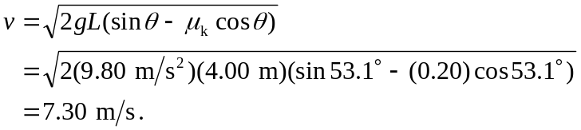
b) This does require energy considerations; the combined work done by gravity and friction is 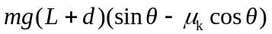, and the potential energy of the spring is 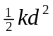, where d is the maximum compression of the spring. This is a quadratic in d, which can be written as
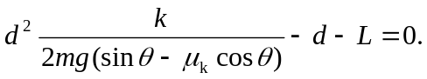

The factor multiplying 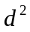 is 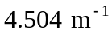, and use of the quadratic formula gives 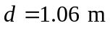. c) The easy thing to do here is to recognize that the presence of the spring determines d, but at the end of the motion the spring has no potential energy, and the distance below the starting point is determined solely by how much energy has been lost to friction. If the block ends up a distance y below the starting point, then the block has moved a distance 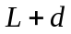 down the incline and 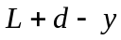 up the incline. The magnitude of the friction force is the same in both directions, 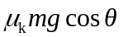, and so the work done by friction is 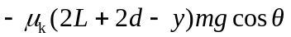. This must be equal to the change in gravitational potential energy, which is 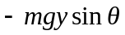. Equating these and solving for y gives
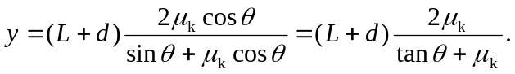

Using the value of d found in part (b) and the given values for 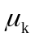 and gives 

